# API INTEGRATION

* 1. **Overview**

An API defines the interfaces by which one piece of software communicates with another at the source level. It provides abstraction by providing a standard set of interfaces - usually functions - that one piece of software (typically a higher-level piece) can invoke from another piece of software (usually a lower-level piece).

For example, an API might abstract the concept of drawing text on the screen through a family of functions that provide everything needed to draw the text. The API merely defines the interface; the piece of software that actually provides the API is known as the implementation of the API.

It is common to call an API a "contract". This is not correct, at least in the legal sense of the term, as an API is not a two-way agreement. The API user (generally, the higher-level software) has zero input into the API and its implementation. It may use the API as-is, or not use it at all: take it or leave it!

A real-world example of an API is the interfaces defined by the C standard and implemented by the standard C library. This API defines a family of basic and essential functions, such as memory management and string manipulation routines.

# List of APIs used in Ahref web App

# [IP](http://ip-api.com/json) Track API

# [Google](https://www.google.com/recaptcha/api) Recaptcha

# [Thum.oi](https://image.thum.io/) screenshot



# IP Track API

You can call the API by sending HTTP GET requests to http://ip-api.com/json/*{query}*

*{query}* can be an IP address or a domain, or none to use the current IP address.

### 

### Example:

You can edit this query and experiment with the options: **http://ip-api.com/json/24.48.0.1**

**Actual Response:**

{

**"query":** "106.192.154.114",

**"status":** "success",

**"country":** "India",

**"countryCode":** "IN",

**"region":** "PB",

**"regionName":** "Punjab",

**"city":** "Ludhiana",

**"district":** "",

**"zip":** "141001",

**"lat":** 30.901,

**"lon":** 75.8573,

**"timezone":** "Asia/Kolkata",

**"isp":** "Bharti Airtel Limited",

**"org":** "Bharti Cellular Limited",

**"as":** "AS45609 Bharti Airtel Limited",

**"mobile":** false,

**"proxy":** false

}

{

**"dns":** {

**"geo":** "India - Bharti Broadband",

**"ip":** "59.144.144.103"

}

}

{

**"mtu":** 1340,

**"link_type":** "OpenVPN TCP bs128 SHA1 lzo",

**"os_name":** "Windows (NT kernel)",

**"user_agent":** "Mozilla/5.0 (Windows NT 10.0; Win64; x64)

AppleWebKit/537.36 (KHTML, like Gecko) Chrome/73.0.3683.103 Safari/537.36"

}

**Once the response is got through the API then this response is converted into json to PHP.**

# Google reCAPTCHA

# reCAPTCHA is a free service that protects your website from spam and abuse. reCAPTCHA uses an advanced risk analysis engine and adaptive challenges to keep automated software from engaging in abusive activities on your site. It does this while letting your valid users pass through with ease.

# Thum.io (URL screenshot capturing services)

# Thum.io provides real-time screenshots of websites. We are the only website snapshot generator to stream screenshots as soon as you request them. Try it out with our free easy to use API.

#### **Example URL**

Screenshot modifier options are placed before the requested URL. See below for a full list of options.

**https://image.thum.io/get/width/100/crop/600/https://www.google.com**

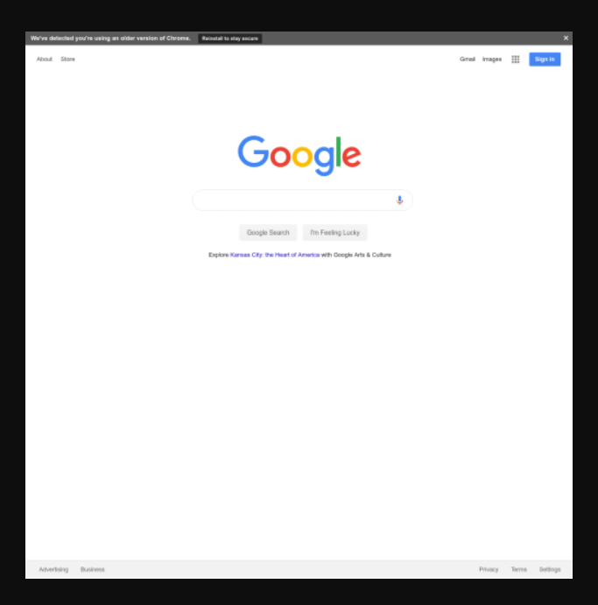

**Fig 4.2.1 Thum.io example**